Step by step process of doing a sprint for bug in Daraz:
- Go to url : https://www.daraz.com.bd/?spm=a2a0e.27096439.header.dhome.50367d1dzgk5eS#
- Then when we change the language to English the language icon change to bangle. The picture below shows that:


- Then create an issue in Jira and add summary, description and assign it to someone in the team to solve the bug .Also for help add the picture of that bug :
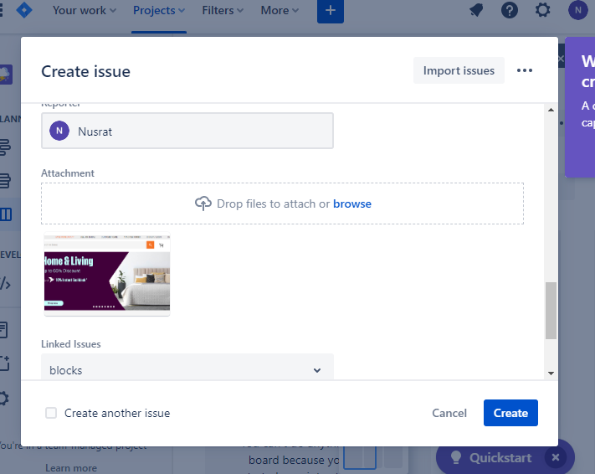

- After creating the it this is what it will look like from start:
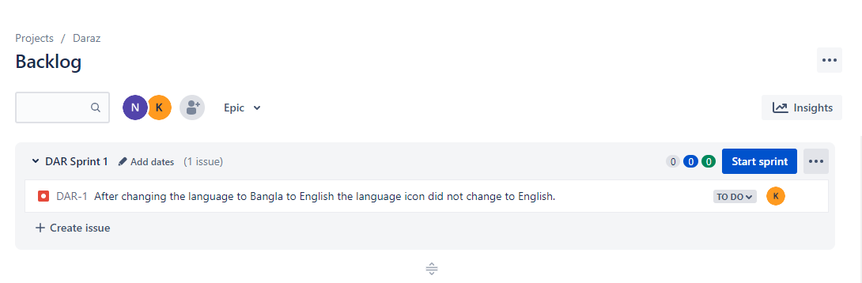
- When the person who gets the work and start doing it ,they will inform as In progress and it will show like this:
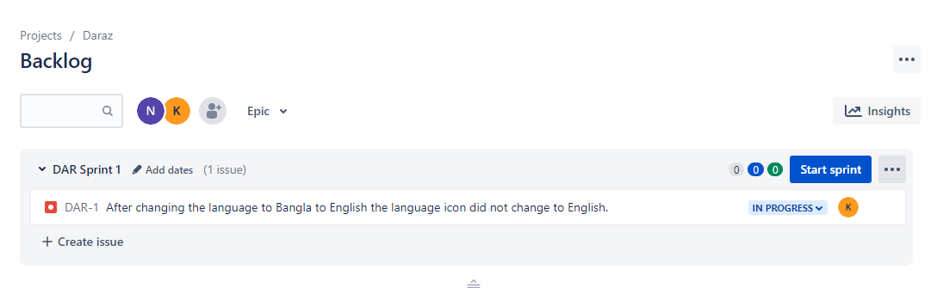
- In the end when it will be done and they will remove the bug they will inform as Done:

